**CMS Remote Playback**

The CMS software allows for remote playback of recorded footage from your cameras.

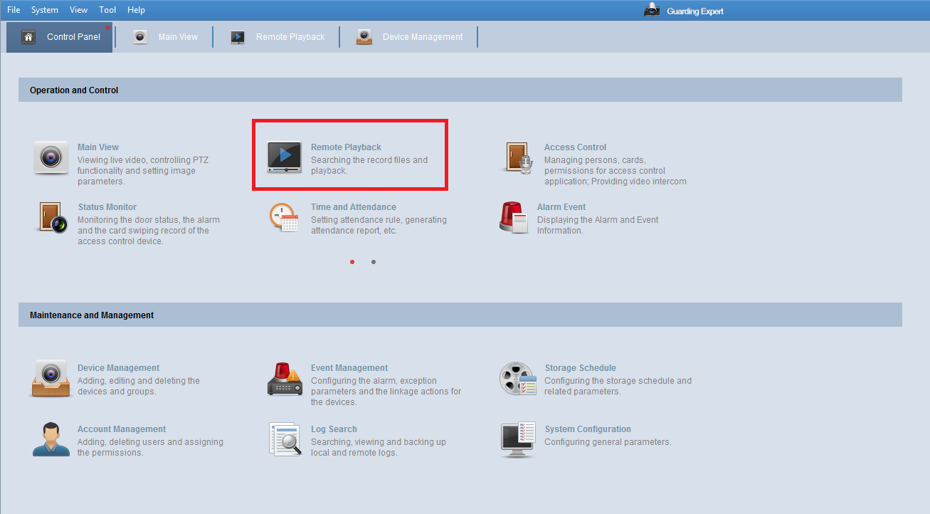

Under the Control Panel is where you will find the Remote Playback option. If it is missing, you will need to go to the Module Customization option to make the option appear.

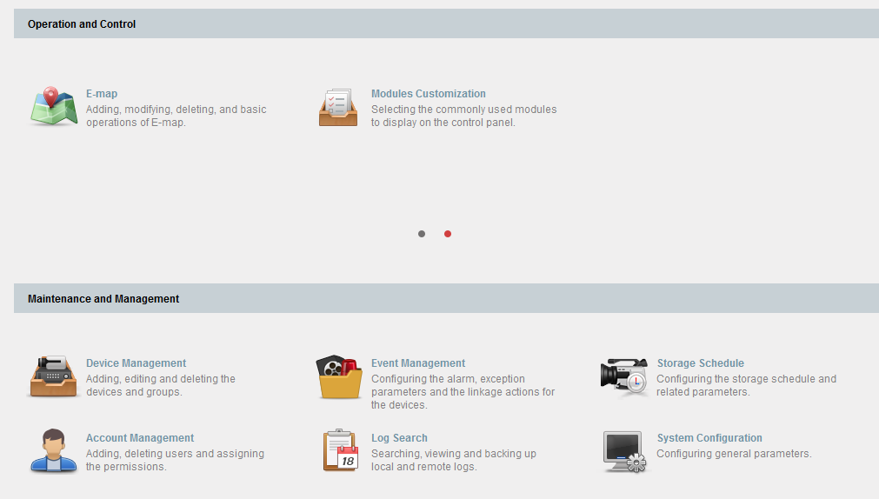

The Remote Playback layout focuses on three areas. The camera listing on the left is imported via the Groups. The cameras would need to be added to Groups for them to show up on the left hand side. Once selecting the camera that you want to view the footage for, you will select the dates. Hit Search and it will generate the footage.

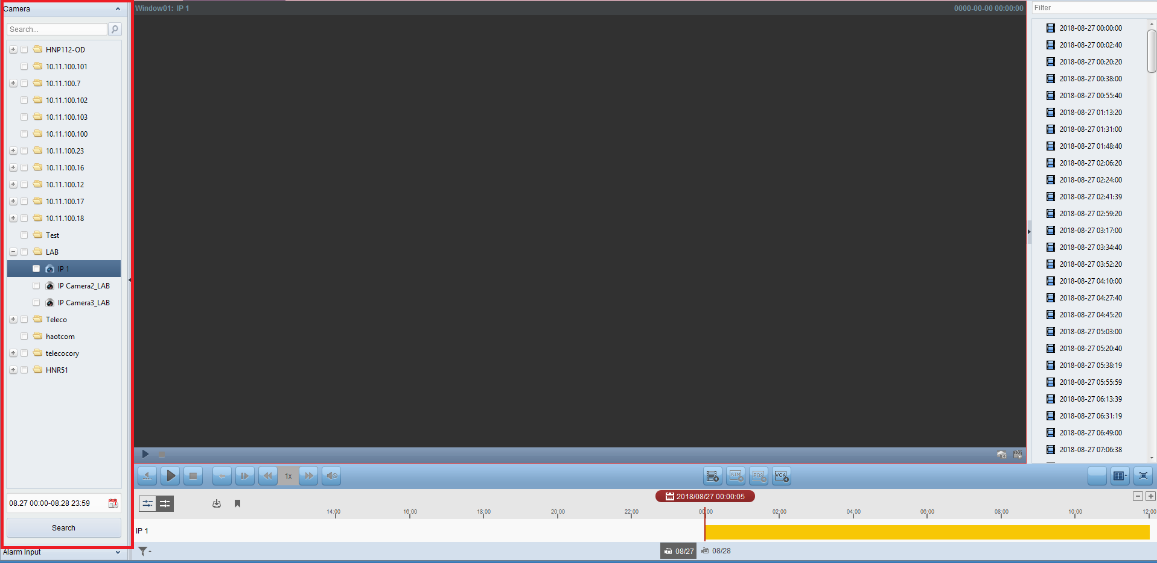

You can have one window of playback, or multiple windows. Multiple windows can be selected in the bottom right corner. This can also be full-screened with the icon next to it.

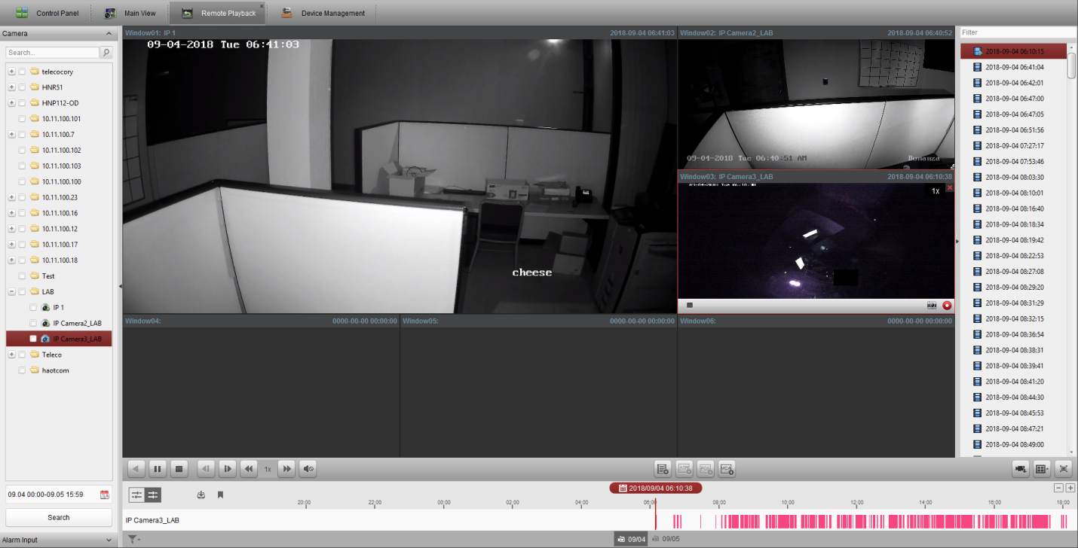

Events and the playback schedule line the bottom of the screen. Events such as motion detection or just the general recordings will be colorized across this bar. Hovering above the times will allow the user to drag it from left to right. You can also skip to different sections with the list on the right hand side of the screen.

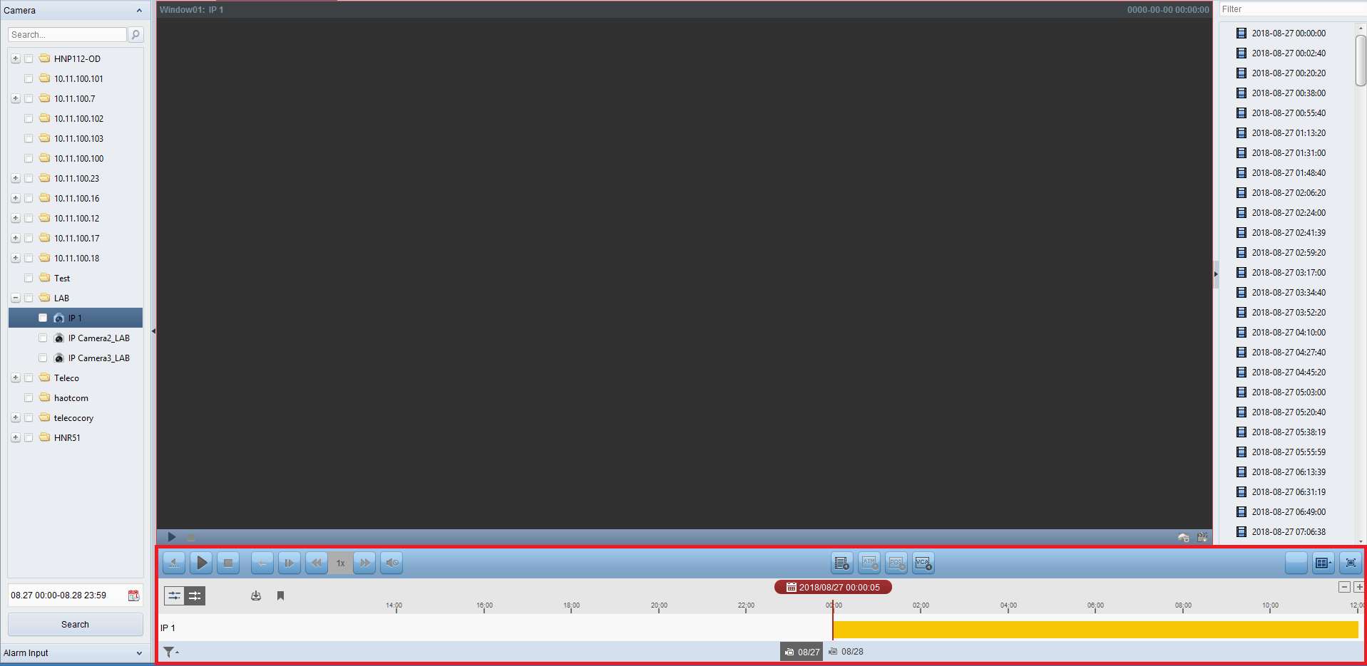

Footage can be downloaded and saved for viewing. Selecting the camera button will bring up a menu for selecting the footage you want to save.



You will be prompted to choose the camera and date range of what you want downloaded from the specific Group Folder you are looking at. There is also an indication of how much free space you have. Make sure download player option is checked.

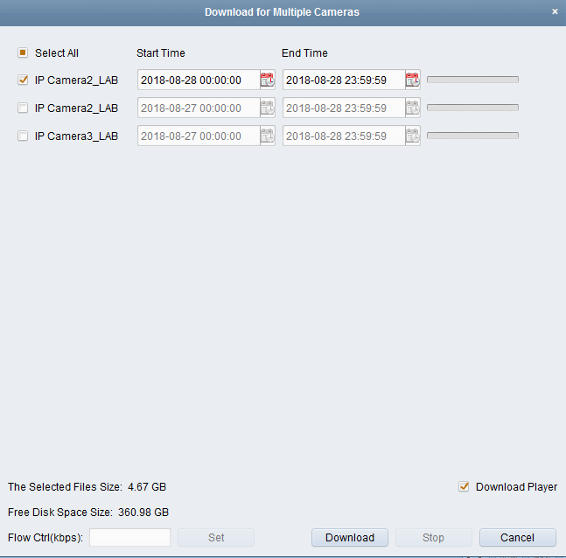

There is also an option to download by files. These are the generated files on the right hand side. There is a tiny button listed above the schedule at the bottom to bring up this prompt.



You can also download by date and tag if the file has been named.

